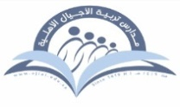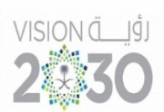**Kingdom of Saudi Arabia Tarbeat Al –Ajial International Schools**



**Ministry of Education American Section**

**Hafr Al Baten Directorate**

**2024/2025**

|  |  |  |  |
| --- | --- | --- | --- |
| **Student’s name** |  | **Grade** | **6** |
| **Subject** | **Computer** | **Week No.** | **4** |
| **Lesson Title** | **Pictograms** | **1st Semester Work sheet No.** | **3** |

**Question A: Fill in the blanks.**

1. The ____________ tool removes the overlaying shape from the parent shape.
2. The ___________ tool adds/merges the selected shapes to create a single shape.
3. Holding the ______________ key allows us to select multiple shapes
4. The size, position and orientation (angle of rotation) can be set in the dimension parameters of the __________ panel.

**Question B: State whether the statements are True/False.**

1. The unite tool removes the overlaying shape from the parent shape.

_____________

1. The toolbar consists of tools that are used to create an artwork.

______________

1. We hold the shift key to select multiple shapes.

______________